

**IFIM COLLEGE**

MBA- 3 SEMESTER

DATA VISUALISATION

Assignment on

Assignment on Movie Classification

PREPARED BY

Miss NEHA R DODDAMANI

P03EH23M015028

SUBMITTED TO

DR. Arpit Yadav

Submission Date: 05.02.2025

**IFIM COLLEGE, ELECTRONIC CITY, BANGALORE**

**Movie Industry**

**Data Analysis & Business Strategy Report**

**Business Understanding**

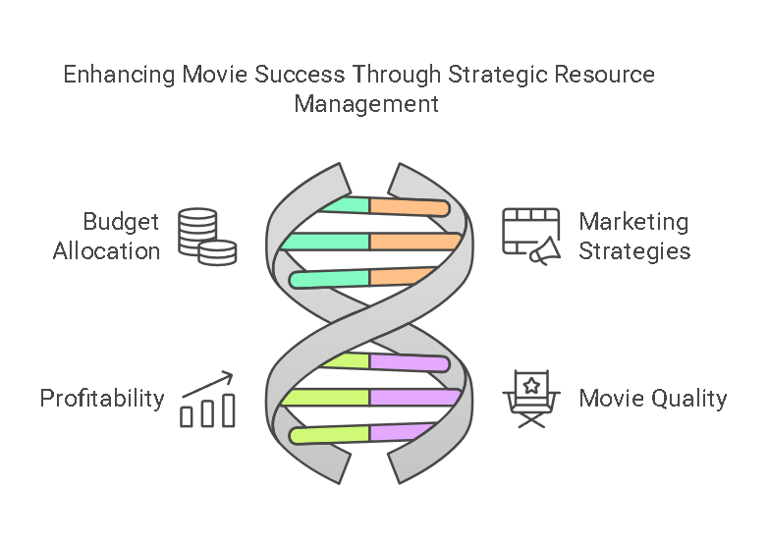The film industry is a multi-billion-dollar sector that requires substantial financial investments and strategic decision-making. Understanding the key factors that drive movie success—such as budget, genre, 3D technology adoption, and technical attributes can enable producers, investors, and distributors to make informed decisions. This analysis aims to uncover trends and relationships between these factors and movie performance. The insights gained will help stakeholders optimize budget allocation, enhance marketing strategies, and maximize profitability while improving overall movie quality.

**Data Requirements**

To conduct a comprehensive analysis, the following key data points were considered

* 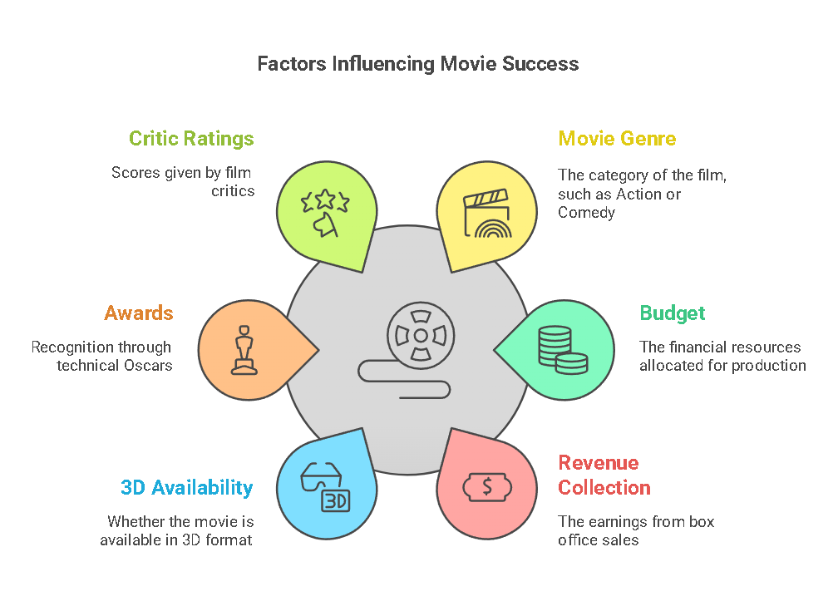**Movie Genre**: Categorized into Action, Thriller, Drama, and Comedy.
* **Budget**: The total production cost allocated for each movie.
* **Revenue Collection**: Box office earnings generated by each movie.
* **3D Availability**: Whether or not the movie was released in 3D.
* **Awards**: The number of technical Oscars won.
* **Critic Ratings**: The average critic rating score

These variables were selected based on their potential impact on financial performance and audience reception.

**Data Collection Sources**

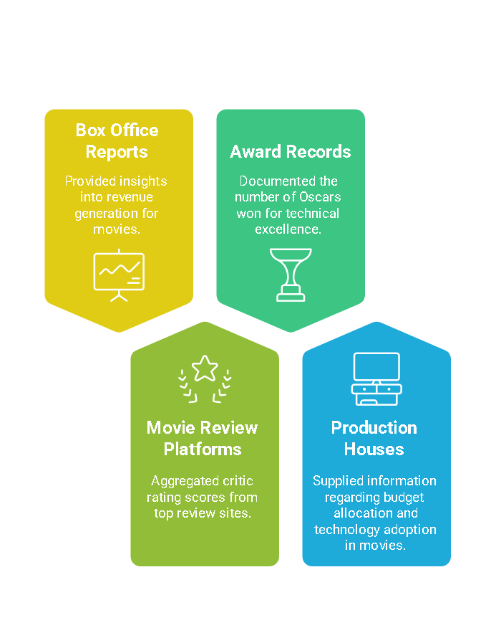The data was meticulously sourced from multiple reputable platforms, ensuring accuracy and reliability:

* **Box Office Reports**: Provided insights into revenue generation for movies.
* **Movie Review Platforms**: Aggregated critic rating scores from top review sites.
* **Award Records**: Documented the number of Oscars won for technical excellence.
* **Production Houses**: Supplied information regarding budget allocation and technology adoption in movies.

Data collection was carried out with a focus on transparency, reliability, and completeness.

**Data Validation & Understanding**

To maintain data integrity and ensure the validity of insights, the collected data underwent a rigorous validation process:

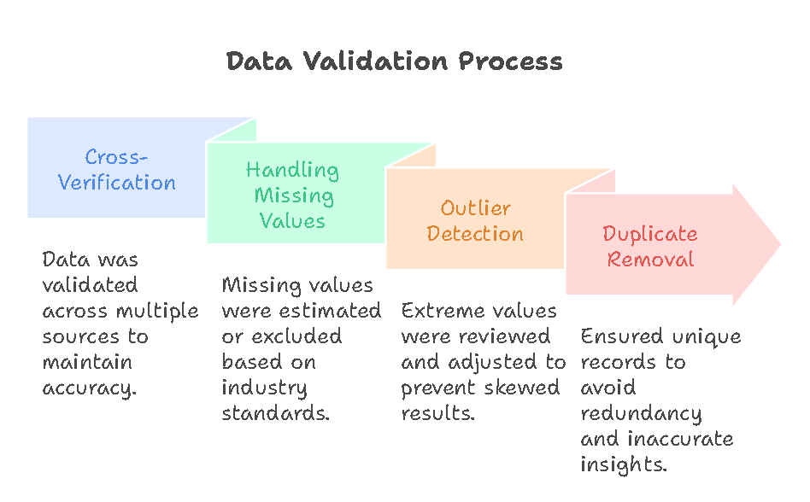

* **Cross-Verification**: Data was validated across multiple sources to maintain accuracy.
* **Handling Missing Values**: Missing values in revenue, budget, or ratings were either estimated using industry standards or excluded if insufficient data was available.
* **Outlier Detection**: Extreme values that deviated significantly from industry norms were reviewed and adjusted to prevent skewed results.
* **Duplicate Removal**: Ensured unique records to avoid redundancy and inaccurate insights.

A thorough understanding of the dataset allowed for accurate and informed analysis.

**Data Cleaning & Preprocessing**

To ensure that the dataset was ready for analysis, the following preprocessing tasks were performed:

* 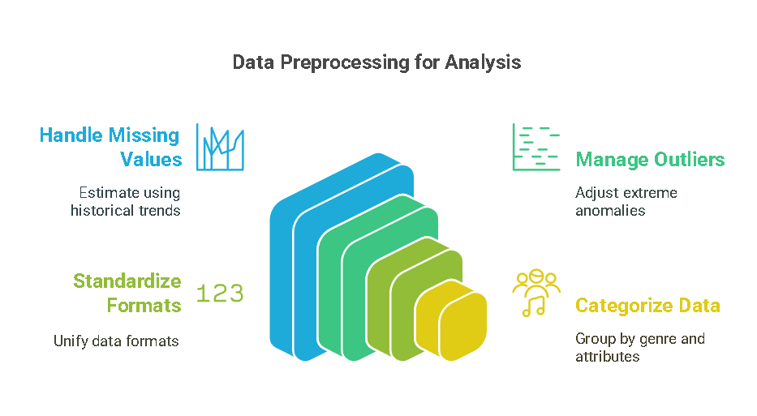**Handling Missing Values**: Where data was incomplete, estimations were made using historical trends.
* **Outlier Management**: Extreme anomalies in budget and revenue data were identified and adjusted where necessary.
* **Standardization**: Budget, revenue, and rating formats were unified for seamless analysis.
* **Categorization**: Movies were grouped by genre, 3D availability, and award status for comparative analysis.

This data cleaning process improved the reliability and consistency of insights.

**Analysis Tools & Methodology**

A combination of analytical tools and techniques was leveraged to extract meaningful insights:

* **Excel**: Used for initial structuring, data cleaning, and basic calculations.
* **Tableau / Power BI**: Utilized for visualization, interactive dashboards, and trend identification.
* **Python / R**: Implemented for advanced statistical analysis, trend detection, and correlation assessments.

These tools facilitated in-depth exploration of relationships between variables and movie success metrics.

**Visualization & Insights (Dashboard Findings)**

The analysis revealed critical insights into industry performance through graphical and statistical representations:

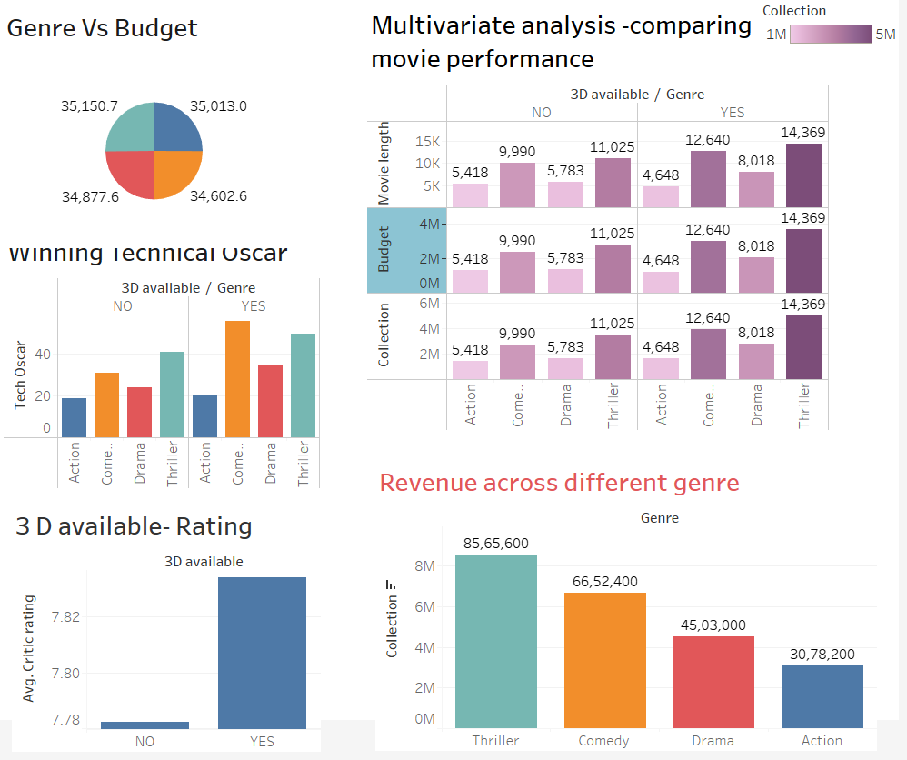

**Genre vs. Budget Allocation**

* Budgets are evenly distributed across genres, suggesting no distinct preference in investment.

**Revenue Performance Across Genres**

* **Thriller movies generate the highest revenue (₹8.56M)**, demonstrating strong audience appeal.
* **Action movies generate the least revenue (₹3.08M)**, indicating a need for revised content and marketing strategies.

**Impact of 3D Technology**

* **Movies released in 3D consistently perform better** in both revenue and critic ratings.
* Higher adoption of 3D technology correlates with increased audience engagement and profitability.

**Role of Technical Oscars**

* **Thriller movies with 3D technology have won the most technical Oscars**, emphasizing the significance of advanced production techniques.
* Winning technical awards enhances a movie's reputation, contributing to audience interest and financial success.

**Multivariate Analysis – Combining Key Factors**

* **3D-enhanced thriller movies significantly outperform other categories** in revenue, critic ratings, and awards.
* Movies with high budgets do **not** always guarantee higher returns, suggesting that strategic spending is more beneficial than excessive funding.

These findings offer crucial insights into optimizing movie production and distribution strategies.

**Key Takeaways & Strategic Insights**

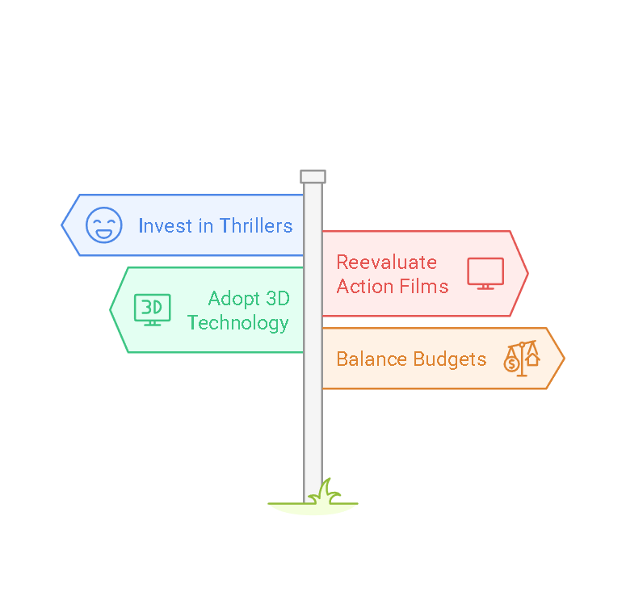**Profitable Genre Trends**

* **Thriller movies emerge as the most profitable genre**, making them a strong investment choice.
* **Action movies underperform financially**, requiring a reevaluation of storytelling, marketing, and production techniques.

**3D Technology as a Revenue Booster**

* Incorporating **3D significantly enhances revenue**, critic ratings, and award potential.
* Future investments should prioritize **3D technology adoption** to improve movie success.

**Budget vs. Revenue Correlation**

* **Higher budgets do not always translate to higher revenue.**
* A **balanced approach to spending, aligned with audience demand, is crucial for profitability.**

**Awards and Technical Excellence**

* **Winning Oscars for technical aspects enhances a movie’s critical perception and audience pull.**
* Investing in **high-quality production techniques** leads to greater market recognition

**Decision-Making Recommendations for Stakeholders**

Based on our findings, the following strategic decisions are advised for industry stakeholders:

1. **Prioritize Thriller and Comedy Genres**
   * Focus investments on these high-performing genres to maximize revenue potential.
2. **Adopt 3D Technology for Competitive Advantage**
   * Encourage the production of 3D movies to enhance visual appeal, attract audiences, and increase box office performance.
3. **Optimize Budget Allocation**
   * Avoid excessive spending on movies that do not align with audience demand.
   * Invest efficiently in production, marketing, and storytelling improvements.
4. **Enhance Technical Quality to Win Awards**
   * Collaborate with award-winning technical teams to improve production standards.
   * Recognizing the impact of technical Oscars, ensure that movies meet high-quality benchmarks.
5. **Revamp Action Movie Strategies**
   * Improve script quality, marketing, and production strategies for action movies to boost financial performance.

**Future Growth Strategy for the Movie Industry**

To ensure sustainable growth and long-term profitability, industry leaders should implement the following strategies:

* **Increase 3D Production**: Invest in advanced technology for visually compelling movies.
* **Strengthen Action Movie Performance**: Revise storytelling and marketing strategies to enhance their appeal.
* **Focus on Award-Winning Potential**: Collaborate with technical experts to improve production quality.
* **Data-Driven Marketing Strategies**: Utilize business intelligence to identify high-performing genres and market accordingly.
* **Implement Cost-Efficient Production**: Focus on strategic budgeting while maintaining quality, ensuring a sustainable return on investment.

By adopting these strategies, stakeholders can drive both financial and critical success in the entertainment industry.

**Conclusion**

This comprehensive analysis provides valuable insights into the key drivers of movie success. The findings emphasize the importance of **selecting profitable genres**, **leveraging 3D technology**, **optimizing budget spending**, and **investing in technical excellence**. By implementing the recommended strategies, stakeholders can enhance movie performance, ensure higher revenues, and strengthen their competitive position in the ever-evolving film industry.

**Adopting a data-driven approach to decision-making will lead to sustainable growth and increased profitability in the entertainment sector.** 🎬📈